**Set Up JDBC Environment**

**Create HTML page**

<!DOCTYPE html>

<html>

<head>

<meta charset="ISO-8859-1">

<title>Insert title here</title>

</head>

<body>

</body>

</html>

**Create Database**

**Create Connection class**

package com.connect;

import java.sql.*;

public class DbConnection {

public static Connection getConnection()

{

Connection con = null;

try

{

Class.*forName*("com.mysql.cj.jdbc.Driver");

con=DriverManager.*getConnection*("jdbc:mysql://localhost:3306/mphasis" , "root", "sonikaSHETTY#17");

}

catch(Exception ex)

{

System.***out***.println(ex);

}

return con;

}

}

**Create Servlet**

import java.io.IOException;

import javax.servlet.ServletException;

import javax.servlet.annotation.WebServlet;

import javax.servlet.http.HttpServlet;

import javax.servlet.http.HttpServletRequest;

import javax.servlet.http.HttpServletResponse;

import java.sql.*;

import com.connect.DbConnection;

/**

* Servlet implementation class Demo

*/

*@WebServlet*("/Demo")

public class Demo extends HttpServlet {

private static final long ***serialVersionUID*** = 1L;

/**

* **@see** HttpServlet#HttpServlet()

*/

public Demo() {

super();

// **TODO** Auto-generated constructor stub

}

/**

* **@see** HttpServlet#service(HttpServletRequest request, HttpServletResponse response)

*/

protected void service(HttpServletRequest request, HttpServletResponse response) throws ServletException, IOException {

// **TODO** Auto-generated method stub

}

/**

* **@see** HttpServlet#doGet(HttpServletRequest request, HttpServletResponse response)

*/

protected void doGet(HttpServletRequest request, HttpServletResponse response) throws ServletException, IOException {

// **TODO** Auto-generated method stub

response.getWriter().append("Served at: ").append(request.getContextPath());

}

/**

* **@see** HttpServlet#doPost(HttpServletRequest request, HttpServletResponse response)

*/

protected void doPost(HttpServletRequest request, HttpServletResponse response) throws ServletException, IOException {

// **TODO** Auto-generated method stub

doGet(request, response);

}

}

**Add servlet api jar using built-path**

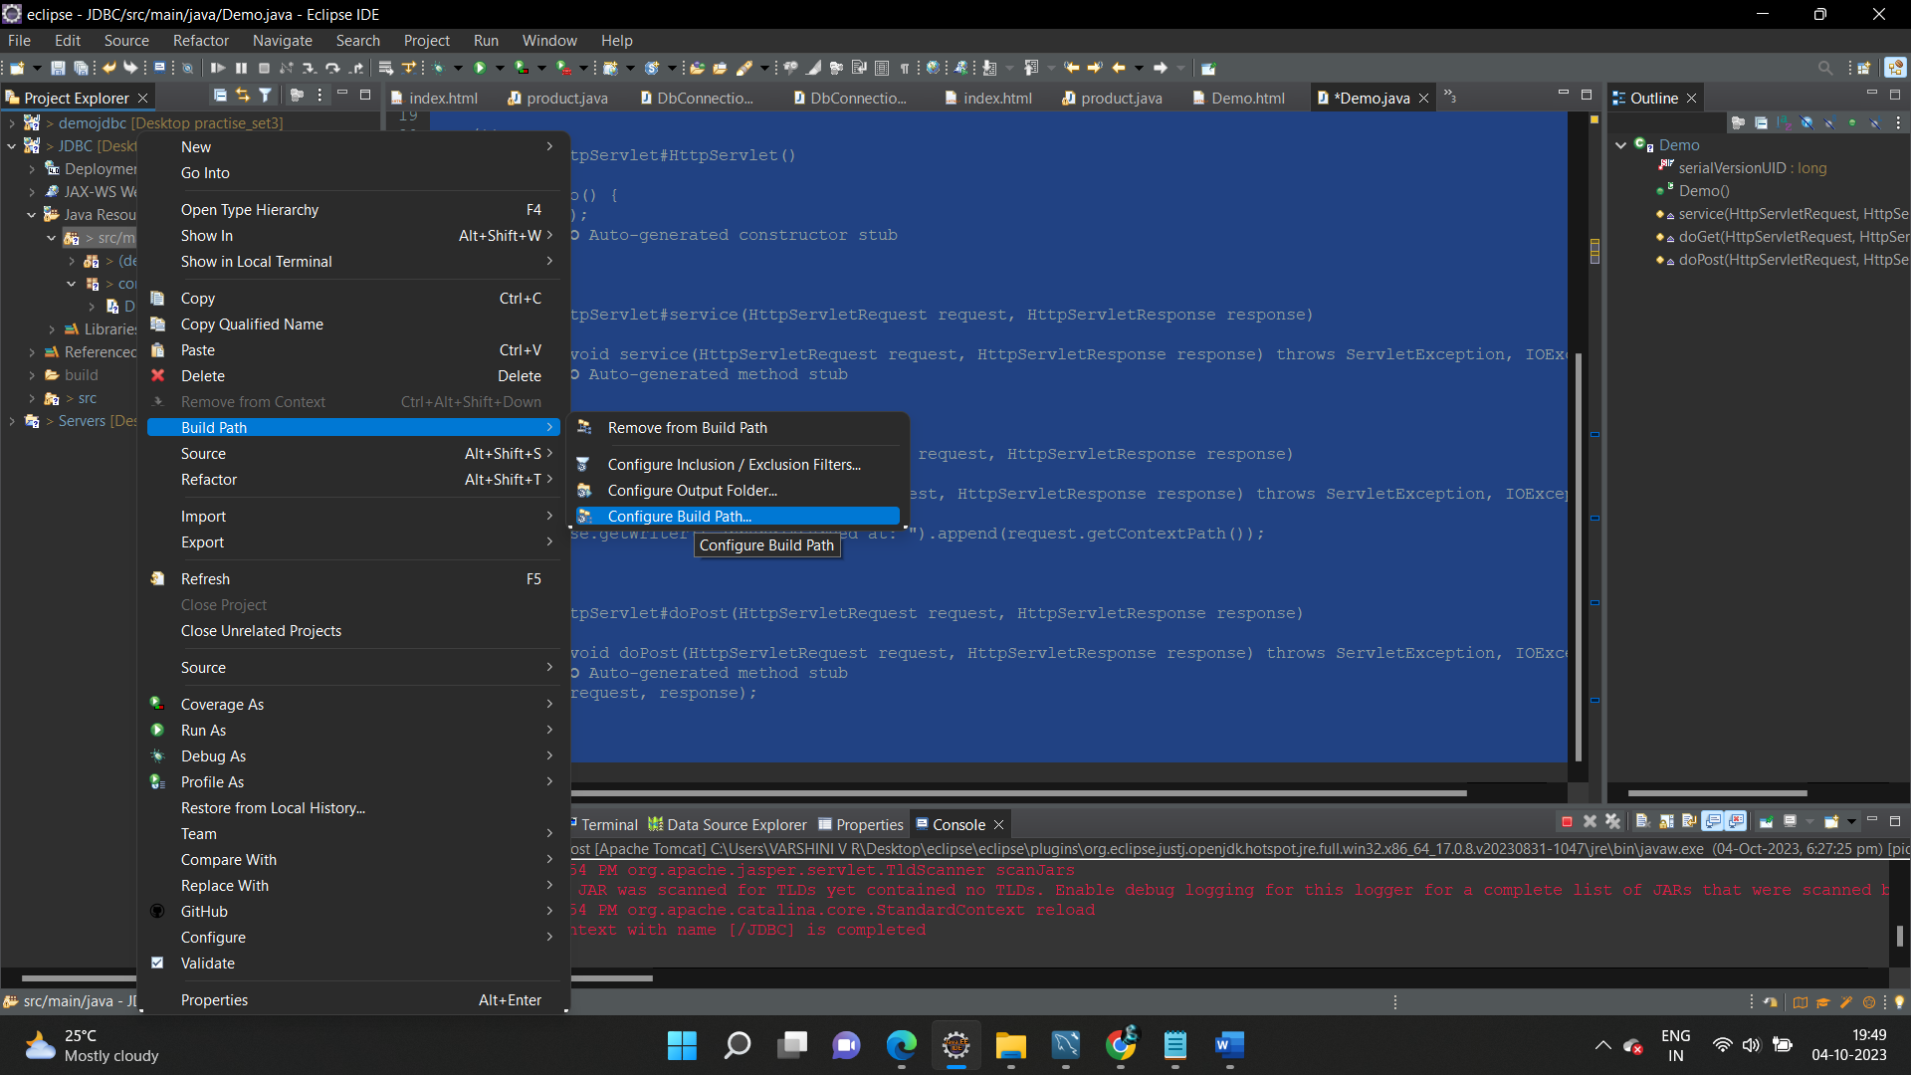

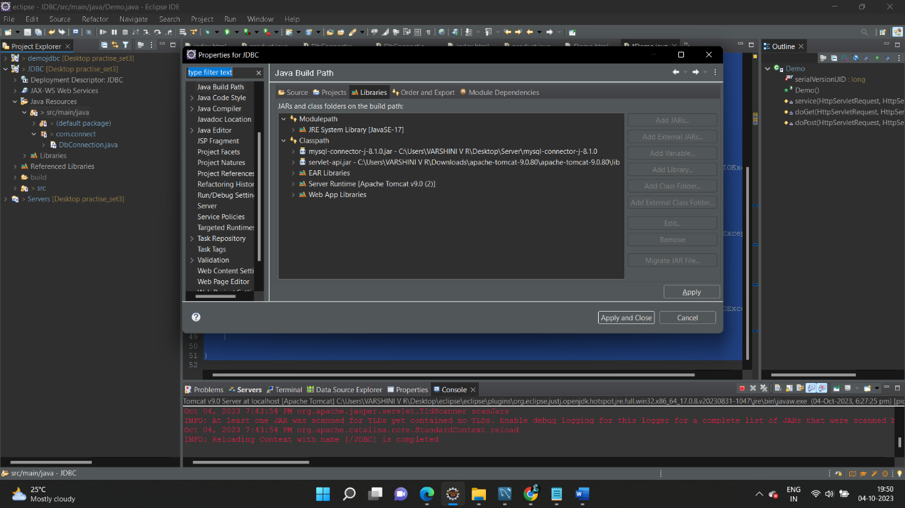

Add my SQL connector jar to lib

